SCHOOL NAME: ______________________________________EXAMINATION NO: _________________

SOUTH EAST EDUCATION DIVISION
2025 MALAWI SCHOOL CERTIFICATE OF EDUCATION MOCK EXAMINATION

BIOLOGY

Subject Number: M022/I
Wednesday, 26th March Time Allowed: 2 hours
8:00 – 10:00 am

PAPER I

THEORY
(100 marks)

Instructions
Question  Number | Tick if answered | Do not write in these columns
1
2
3
4
5
6
7
8
9
10
11
12
13
- This paper contains 8 printed pages.
Please check.

- Fill in your Examination Number and School Name on top of each page.

- This paper contains two sections, A and B. In Section A there are ten short answer questions while Section B has three restricted essay questions.

- Answer all the thirteen questions in the spaces provided.

- Use of electronic calculators is allowed.

- The maximum number of marks for each answer is indicated against each question.

- In the table provided on this page, tick against the number of question you have answered.

© 2025 SEED MOCK Turn over/…

Section A (70 marks)
Answer all the questions in this section
- (a) Define the term conditioning as described in reflex actions
_________________________________________________________________________________________________________________________________________________(2 Marks)
(b) Name three steps in conditioning
______________________________________________________________________________________________________________________________________________________________________________________________________________________________(3 Marks)
(c) State one importance of reflex actions in animals.
____________________________________________________________________ (1Mark)
(d) Name two reflex action that are under the control of the brain.
_______________________________________________________________________________________________________________________________________________(2 Marks)
- (a) State one difference between nastic responses and tropisms.
____________________________________________________________________ (1Mark)
(b) Figure 1 is a diagram showing an investigation on the influence of auxin on phototropism. Study the diagram and use it to answer the questions that follow
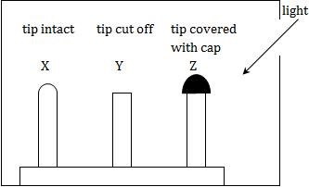
Figure 1
(c) Draw what will be observed after three weeks.

(3 Marks)
(d) Explain why there would be the observation seen above after three weeks.
_______________________________________________________________________________________________________________________________________________(2 Marks)
Continued/…

3. The equation below shows a process that happens in plants. Study it and use it to answer the questions that follow.
2H₂O 4H + K
- Name the process shown above
____________________________________________________________________ (1Mark)
- Identify K
____________________________________________________________________ (1Mark)
(c) Mention two things that happens to K after production.
___________________________________________________________________________________________________________________________________________________(2 Marks)
(d) State any two factors that affect the rate of diffusion of substances.
___________________________________________________________________________________________________________________________________________________(2 Marks)

4. (a) Define the term tidal volume.
____________________________________________________________________ (1Mark)
(b) Explain briefly how the medulla oblongata regulates the breathing rate.
___________________________________________________________________________________________________________________________________________________________________________________________________________________________(3 Marks)
(c) Figure 2 is a diagram showing gaseous exchange in leaves at different times of the day. Study it and answer the questions that follow
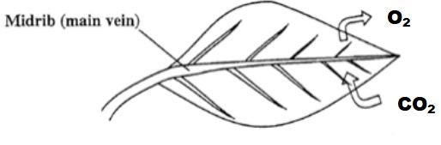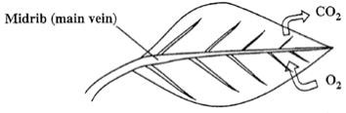
A Figure 2 B
(d) Identify the time of the day as shown by each of the leaves above
A_________________________________________________________________ (1Mark)
B_________________________________________________________________ (1Mark)

Continued/…
(e) Explain what causes the leaf to exchange gases as shown in figure B.
_______________________________________________________________________________________________________________________________________________________________________________________________________________________(3 Marks)
5. Figure 3 is a diagram showing blood cells labelled Y and Z. Study it and answer the questions that follow.
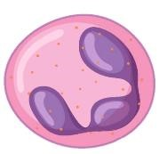
Y Figure 3 Z
- State the functional difference between cells labelled Y and Z
____________________________________________________________________ (1Mark)
- State one adaptation of Y to its function
____________________________________________________________________ (1Mark)
- Explain how cell Z carry out its function.
_______________________________________________________________________________________________________________________________________________(2 Marks)
d. Name any two examples of first line defence in human body.
_______________________________________________________________________________________________________________________________________________(2 Marks)
e. Explain how would a wound on a finger results in a painful swelling in the armpit.
_______________________________________________________________________________________________________________________________________________(2 Marks)

6. Figure 4 is a diagram showing a sperm. Study it and answer the questions that follow.
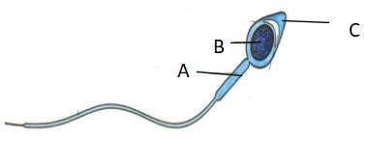
Figure 4
- What is contained in the part labelled B
____________________________________________________________________ (1Mark)
- State the function of the enzyme found in part C.
____________________________________________________________________ (1Mark)
Continued/…
- How does part A help in the locomotion of the sperm.
____________________________________________________________________ (1Mark)

7. In an ecosystem, a student observed that grasshoppers were feeding on grass. After she left, birds came and pick up the grasshoppers. Use this information to answer the questions that follow.
- Draw a food pyramid in this ecosystem.
(3
Marks
)
- Explain how energy is flowing in this ecosystem as stated above.
_______________________________________________________________________________________________________________________________________________(2 Marks)

8. (a) State the Mendelian Law of Independent assortment.
____________________________________________________________________ (1Mark)
(b) Explain why Mendelian experiments are referred to as monohybrid crosses.
_______________________________________________________________________________________________________________________________________________(2 Marks)
(c ) Why are sex-linked characteristics more common in males than in females.
_______________________________________________________________________________________________________________________________________________(2 Marks)
(d) Name any two applications of biotechnology in agriculture
_______________________________________________________________________________________________________________________________________________(2 Marks)
(e) Explain how insulin is produced through genetic engineering.
___________________________________________________________________________________________________________________________________________________________________________________________________________________________(3 Marks)

Continued/…
9. (a) Mention two hormones involved in osmoregulation.
_______________________________________________________________________________________________________________________________________________(2 Marks)
- Table below shows the concentration of substances in blood and urine
Substance | Protein concentration (g/l)
Blood | 65.00
Urine | 0.00
(c). Explain why proteins are only found in blood plasma
_______________________________________________________________________________________________________________________________________________(2 Marks)
(d). What name is given to conditions where proteins are found in urine?
____________________________________________________________________ (1Mark)
(e) Explain how the process of ultrafiltration in glomerulus occurs
_______________________________________________________________________________________________________________________________________________(2 Marks)

10. Figure 5 is a diagram showing a neuron. Study the diagram and answer the questions that follow.
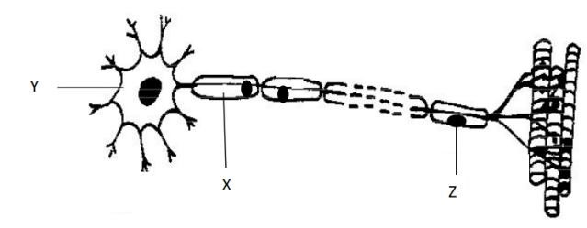
Figure 5
- Identify the type of neurone shown in the diagram
____________________________________________________________________ (1Mark)
- Name the parts labelled X and Y
X_______________________________________________________________ Y______________________________________________________________ (2Marks)
- State the function of the part labelled Z
___________________________________________________________________ (1Mark)
- Explain the effect in a person if the neurone shown above is damaged.
___________________________________________________________________________________________________________________________________________ (2 Marks)
Continued/…
- Name any two examples of reflex actions that are controlled by the spinal cord
__________________________________________________________________________________________________________________________________________ (2 Marks)

SECTION B (30 MARKS)
Answer all the three questions in this section. Your answers should be in an essay form.
11. Describe five adaptations of small intestines to digestion and absorption of food.
_____________________________________________________________________________________________________________________________________________________________________________________________________________________________________________________________________________________________________________________________________________________________________________________________________________________________________________________________________________________________________________________________________________
_________________________________________________________________________________________________________________________________________________________________________________________________________________________________
__________________________________________________________________________________________________________________________________________________________________________________________________________________________________________________________________________________________________________________________________________________________________________________________________________________________________________________________________
__________________________________________________________________________________________________________________________________________________________________________________________________________________________________________________________________________________________________________________________________________________________________________________________________________________________________________________________________
_________________________________________________________________ (10 marks)
12. Explain any five similarities in the adaptations of birds to locomotion and adaptations of
fish to locomotion
_____________________________________________________________________________________________________________________________________________________________________________________________________________________________________________________________________________________________________________________________________________________________________________________________________________________________________________________________________________________________________________________________________________
Continued/…
______________________________________________________________________________________________________________________________________________________________________________________________________________________________________________________________________________________________________________________________________________________________________________________________________________________________________________________________________________________________________________________________________________________________________________________________________________________________________________________________________________________________________________________________________________________________________________________________________________________________________________________________________________________________________________________________________________________________________________________________________________________________________________________________________________________________________________________________________________________________________________________________________________________________________ (10 marks)
13. A farmer placed a charcoal burner to provide warmth to the chicks in a poultry house. He closed all the windows and went to sleep. The next morning, he found all the chicks dead. Describe how the charcoal burner led to the death of the chicks
______________________________________________________________________________________________________________________________________________________________________________________________________________________________________________________________________________________________________________________________________________________________________________________________________________________________________________________________________________________________________________________________________________________________________________________________________________________________________________________________________________________________________________________________________________________________________________________________________________________________________________________________________________________________________________________________________________________________________________________________________________________________________________________________________________________________________________________________________________________________________________________________________________________________________________________________________________________________________________________________________________________________________________________________________________________________________________________________________________________________________________________________________________________________________________________________________________________________________________________________________________________________________________________________________________________________________________________________________________________________________________________________ (10 marks)
END OF QUESTION PAPER
NB: This paper contains 8 printed pages

